DFS Plan – Adam Riley

I’m making a basic 2D realtime RTS adventure with the purpose of exploring an ECS paradigm. I’m going to base the combat off The Realm of the Mad God. Maps will be grid based but the movement and abilities of entities will be free. I want simple interactive UI for NPC interaction. I want a quest system that will be the driving force of the player through the game. If time allows, I want multiple levels that the player can explore.

The controls are intended to use wasd and the mouse for interaction and abilities. Possible controller support may be added.

The first level layout is as follows:

* 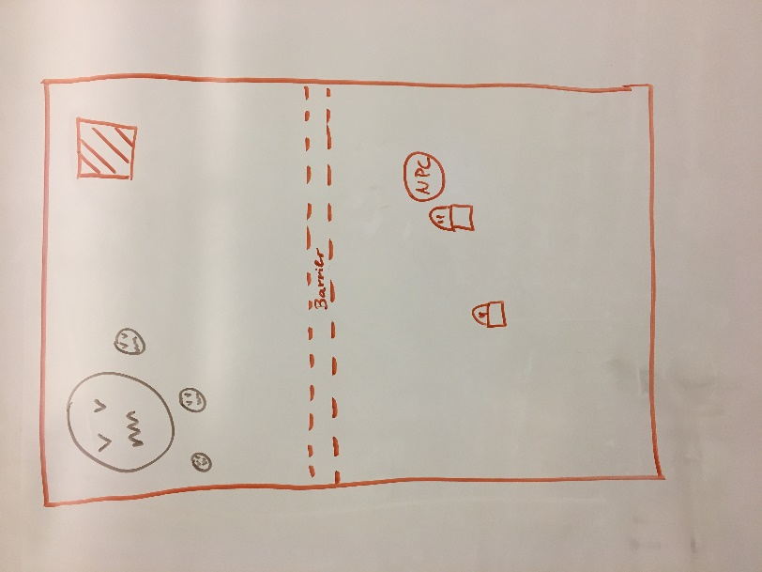Player starts at the bottom of the map.
  + Map is incursion style
* There is a barrier preventing the player from leaving bottom side.
* 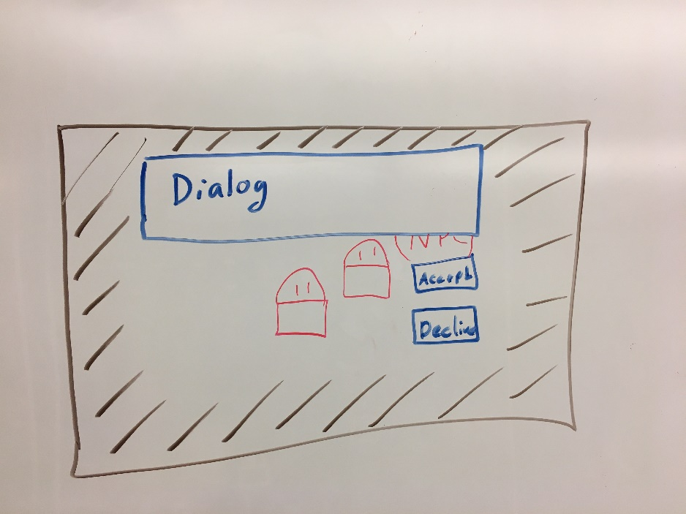The NPC is there ready to talk too.
  + NPC gives quest to kill enemies above barrier
* When interacting the player’s input is consumed by the UI system.
* Can Accept or decline.
  + First pass, decline just exits the Dialog without any consequences.
  + Second pass, there are consequences for declining quests.
* Camera is centered on player
* 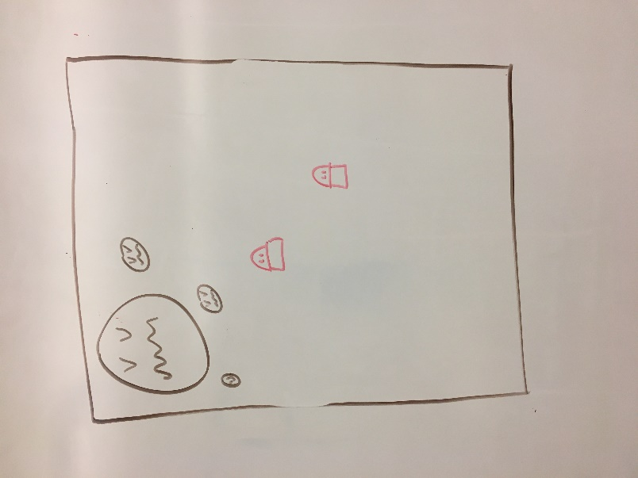Once, quest is accepted, you can pass through invisible barrier
* 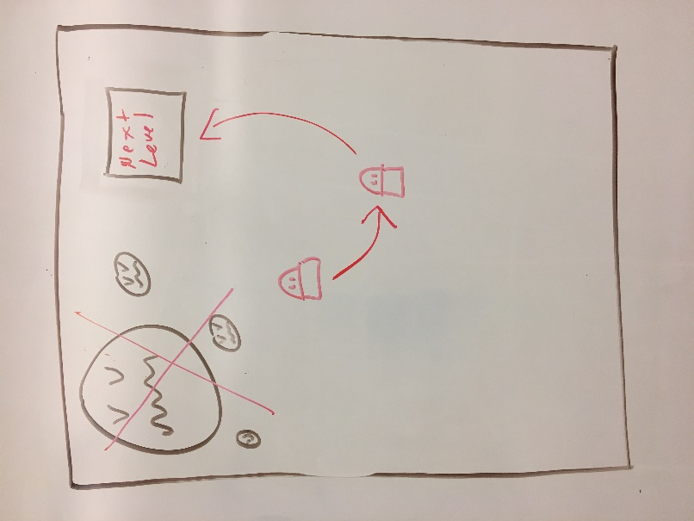Once, the quest is complete, Return to the giver to finish it. This will open a door to the next level.
* Once level one is done, other levels can be made but not required. Only if time allows.

Consequences to failing or declining quests will result in the quest failing, this in turn will effect that map in a negative way. Maybe the NPC dies, making other paths closed to you. This could open alternate paths later. Note that this is a stretch goal.

Entity Component System

The rules that I would like to follow in the code I’m going to use this in are:

* Components only hold data, do no logic
* Systems only preform logic, have no data

This is to explore how easy it is to begin and add to games using this structure.

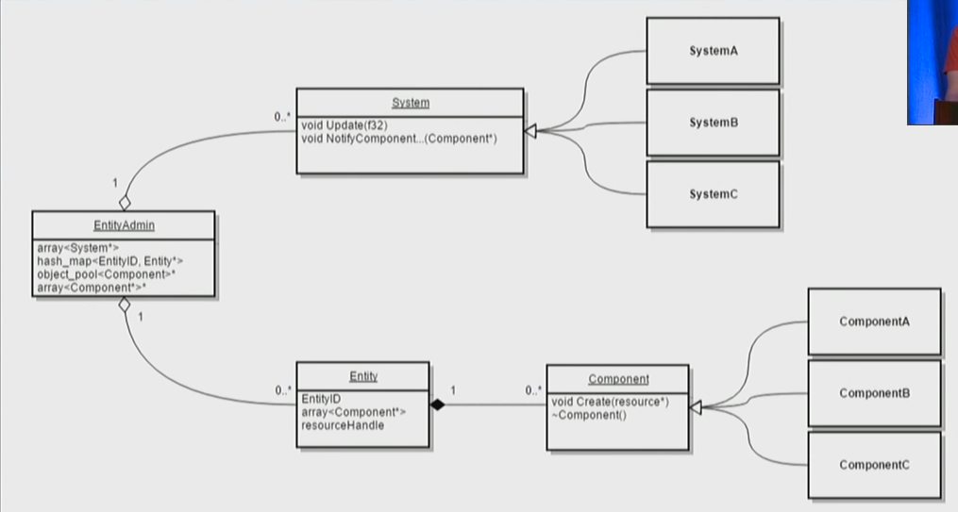References: https://www.youtube.com/watch?v=W3aieHjyNvw&feature=emb_logo

|  |  |  |
| --- | --- | --- |
|  |  | **Schedule** |
| **Week** | **DATE** | **DUE** |
| 1 | Jan 17 | Project Planning |
| 2 | Jan 21,24 | Project planning and Architecture |
| 3 | Jan 28,31 | Get Map setup and player moving – 4 hours  Get NPC made and interact – 4 hours |
| 4 | Feb 4,7 | Get UI and interactions – 4 hours   * Including starting the quest   Rendering and animation – 4 hours |
| 5 | Feb 11,14 | *** Out of town *** DICE Conference *** |
| 6 | Feb 18,21 | * Create more detailed schedule ** - 1.5 hour   Quest   * When close enough to NPC, interact key appears on it – 30 mins * Interact with NPC – (1.5 hours)   + Give quest – 1 hour   + Create Dialog box – 30 mins   Combat   * Get Enemies to spawn – (1 hour)   + Render enemy – 30 mins   + Place enemies correctly – 15 mins   + Correct components on enemies – 15 mins * Player can fire visible bullet – 1 hour * Bullet can die after 1 sec – 30 mins |
| 7 | Feb 25,28 | Physics   * Dynamic Physics components collide with solid walls – 1.5 hours * Dynamic Physics components collides with other Physics components – (45 mins)   + Dynamic – 30 mins   + Static – 15 mins * Keeps a list of ids that it collided with for other systems to reference – 15 mins   Combat 2.0   * Bullet can collide with enemy – 15 mins * Enemies can take damage – 15 mins * Enemies can die – 15 mins * Get enemies to fire back at player when in range – 30 mins * Get enemies to move toward player when in range – 30 mins |
| 8 | Mar 3,6 | **Midterm Presentation – Prep** |
| **9** | **Mar 10,13** | **Midterm Presentations** |
| 10 | Mar 17,20 | *** Out of Town *** GDC *** (Spring Break) |
| 11 | Mar 24,27 | Quest Finish   * Quest get’s updated when an enemy dies, if its part of the quest – 30 mins * Finish Quest and trigger exit to level –   + When all elements are complete, tells player to complete quest – 30 mins   + When interacting with player on complete, give different dialog – 30 mins   Exit   * Exit has two states – (45 mins)   + Closed – Doesn’t nothing when player in range – 15 mins   + Open – Teleports player to destination when player is in range – 30 mins   Quest Finish 2.0   * Trigger Exit to Level   + When interacting with player on completed quest, trigger the exit to activate – 45 mins   + Dialog box goes away on second interact or out of range – 15 mins   Invisible barrier – Unknown, time may change   * Have invisible barrier cutting across level, player can’t cross it – 1 hour * On Quest accept, (fist interact) turn off the barrier, not delete – 1 hour |
| 12 | Mar 31, Apr 3 | * Create Level 2 – (2 hours)   + Like level 1 but can go back to previous level – 1 hour   + Get NPC in with quest setup – 30 mins   + Get Enemies in attached to quest – 30 mins   + No barrier – 0 mins   + Two exits – 1 hour     - 1 open that player can go back to prev level from     - 1 that begins closed that will open on quest complete   Polish Graphics   * Animations – (5 hours)   + Base animation setup – 2 hours   + Boss – 30 mins   + Enemies – 30 mins   + NPC – 30 mins   + Player – 30 mins   + Projectiles – 1 hour |
| 13 | Apr 7,10 | Do either of the stretch goals   * XML setup of map layouts. - ?( Can’t tell till the components are made.) * Quest fail / decline consequences – Stretch goal – 3 hours   + When all elements are complete, tells player to complete quest * Create multiple levels – Stretch goal – 2-6 hours |
| 14 | Apr 14,17 | Presentation Prep / Ludum Dare Weekend |
| 15 | Apr 21,24 | Final Project Submissions and Presentations – Due  Presentation Prep |
| 16 | Apr 28 May 1 | **Final Presentations, Part 1** |
| **17** | **5/5** | Reading Day |
| **17** | **Wednesday**  **5/6** | **Final Presentation - 11 am** |